Daniel Meyer

CSE 420-01

Lab 8

Transformations

**Lab 8 Report**

**Part 1: (Success)**

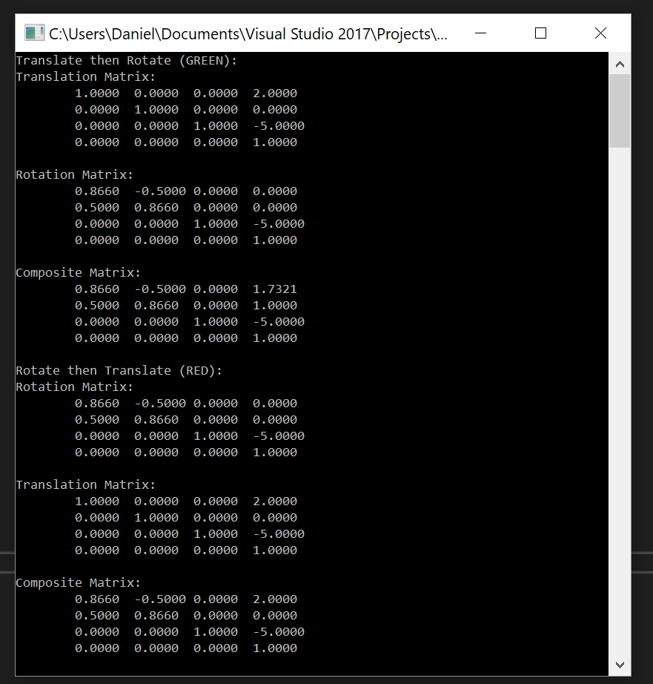

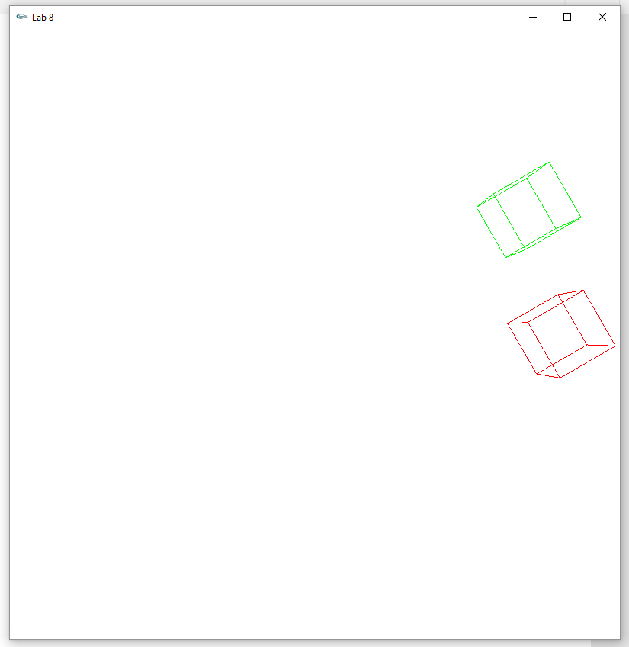

Green Cube -> Translate then Rotate

Red Cube -> Rotate then Translate

void display(void)

{

float p[4][4];

double pd[4][4];

glClear(GL_COLOR_BUFFER_BIT);

glMatrixMode(GL_PROJECTION);

glLoadIdentity(); // clear the matrix

// viewing transformation

glFrustum(-1.0, 1.0, -1.0, 1.0, 2.0, 20.0);

glMatrixMode(GL_MODELVIEW); // position and aim the camera

glLoadIdentity();

gluLookAt(0.0, 0.0, 5.0, 0.0, 0.0, 0.0, 0.0, 1.0, 0.0);

cout << "Translate then Rotate (GREEN):" << endl;

glColor3f(0.0, 1.0, 0.0); //green color

glPushMatrix();

glTranslatef(2.0, 0.0, 0.0);

glGetDoublev(GL_MODELVIEW_MATRIX, &pd[0][0]);

cout << "Translation Matrix:" << endl;

print_mat(pd);

glPopMatrix();

glPushMatrix();

glRotatef(30, 0, 0, 1);

glGetDoublev(GL_MODELVIEW_MATRIX, &pd[0][0]);

cout << "Rotation Matrix:" << endl;

print_mat(pd);

glPopMatrix();

glPushMatrix();

glRotatef(30, 0, 0, 1);

glTranslatef(2.0, 0.0, 0.0);

glGetFloatv(GL_MODELVIEW_MATRIX, &p[0][0]);

cout << "Composite Matrix:" << endl;

print_mat(p);

glutWireCube(0.5);

glPopMatrix();

cout << "Rotate then Translate (RED):" << endl;

glColor3f(1.0, 0.0, 0.0); //red color

glPushMatrix();

glRotatef(30, 0, 0, 1);

glGetDoublev(GL_MODELVIEW_MATRIX, &pd[0][0]);

cout << "Rotation Matrix:" << endl;

print_mat(pd);

glPopMatrix();

glPushMatrix();

glTranslatef(2.0, 0.0, 0.0);

glGetDoublev(GL_MODELVIEW_MATRIX, &pd[0][0]);

cout << "Translation Matrix:" << endl;

print_mat(pd);

glPopMatrix();

glPushMatrix();

glTranslatef(2.0, 0.0, 0.0);

glRotatef(30, 0, 0, 1);

glGetFloatv(GL_MODELVIEW_MATRIX, &p[0][0]);

cout << "Composite Matrix:" << endl;

print_mat(p);

glutWireCube(0.5);

glPopMatrix();

glFlush();

}

**Part 2: (Success)**

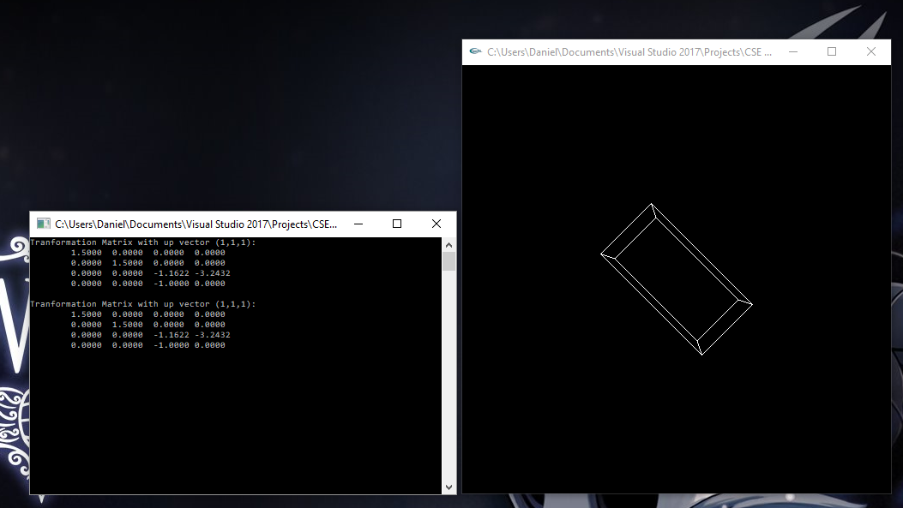

gluLookAt(0.0, 0.0, 5.0, 0.0, 0.0, 0.0, 1.0, 1.0, 1.0);

glScalef(1.0, 2.0, 1.0);

glutWireCube(1.0);

glGetDoublev(GL_PROJECTION_MATRIX, &pd[0][0]);

cout << "Tranformation Matrix with up vector (1,1,1):" << endl;

print_mat(pd);

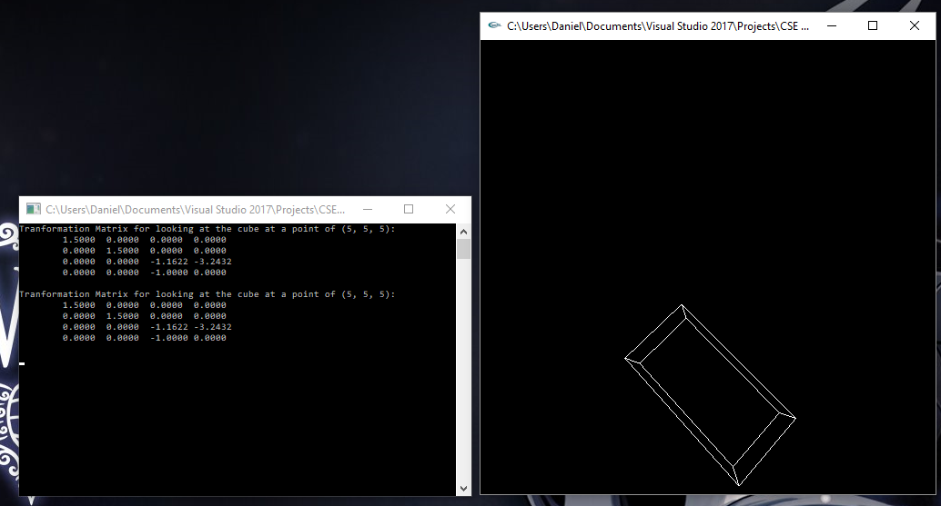

gluLookAt(0.0, 0.0, 5.0, 1.0, 1.0, 1.0, 1.0, 1.0, 1.0);

glScalef(1.0, 2.0, 1.0);

glutWireCube(1.0);

glGetDoublev(GL_PROJECTION_MATRIX, &pd[0][0]);

cout << "Tranformation Matrix for looking at the cube at a point of (5, 5, 5):" << endl;

print_mat(pd);

**Extra Credit: (Success)**

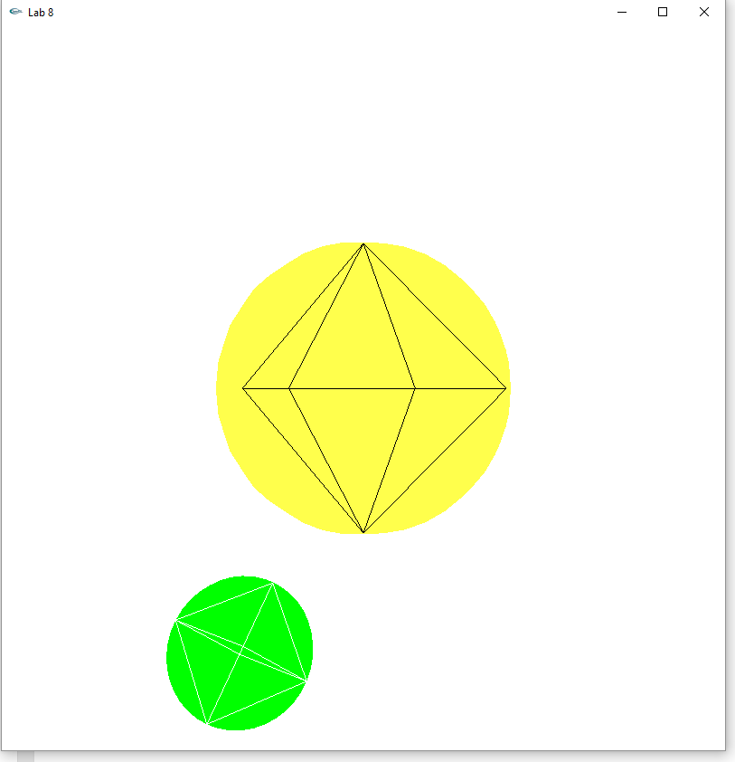

Sun (Yellow Sphere) rotates about y-axis.

Earth (Green Sphere) rotates about its own y-axis and then translated 2 units on the x-axis then rotated about the z-axis.

void init(void)

{

glClearColor(1.0, 1.0, 1.0, 0.0);

glShadeModel(GL_SMOOTH);

glMatrixMode(GL_PROJECTION);

glLoadIdentity();

}

void display(void)

{

glClear(GL_COLOR_BUFFER_BIT);

glMatrixMode(GL_PROJECTION);

glLoadIdentity(); // clear the matrix

glFrustum(-1.0, 1.0, -1.0, 1.0, 2.0, 20.0);

glMatrixMode(GL_MODELVIEW); // position and aim the camera

glLoadIdentity();

gluLookAt(0.0, 0.0, 5.0, 0.0, 0.0, 0.0, 0.0, 1.0, 0.0);

glPushMatrix();

glRotatef(ay, 0, 1, 0);

glColor3f(1, 1, 0.5);

glutSolidSphere(1.0, 20, 20);

glColor3f(1, 1, 1);

glutWireSphere(1.0, 4, 2);

glPopMatrix();

glPushMatrix();

glRotatef(ay, 0, 0, 1);

glTranslatef(2, 0, 0);

glRotatef(ay, 0, 1, 0);

glColor3f(0, 1, 0);

glutSolidSphere(0.5, 20, 20);

glColor3f(1, 1, 1);

glutWireSphere(0.5, 4, 2);

glPopMatrix();

glFlush();

}

**Summary:**

For the first part of this lab I created a cube and performed two different transformation cases. The first case was to perform a translation along the x-axis followed by a rotation about the z-axis. The second case was to rotate about the z-axis and then translate along the x-axis. After each transformation I printed out the matrix as well as the composite matrices for each case. The second part of the lab required I create a glutWireCube and then experiment with the camera using gluLookAt(). I performed the suggested cases of an up vector, causing the cube to appear angled, and looking at a specific point, causing the cube to appear lower on the screen. The transformation matrices for the projection matrix were printed for each. Finally for the extra credit portion we were asked to create two spheres, one for the sun (yellow) and one for the earth (green). These were then supposed to perform their respective rotations: the sun about its own axis and the earth about its own axis and the sun. Each step of the program compiled and ran without error. As a result I believe I earned the total 40 points (20 for lab, 20 for EC).